**Task 1** :

responsive analysis on the deakin website using desktop shows the images and canvas and divisions resize and form to the browser. However while on phone the website is resized and uses a scroll feature to go through the content with a drop down menu featuring the links. Through both devices they use percentages to form the page based on the device dimensions.

Cloud deakin website is broad and open with links and and are resized especially with pdf files and images. However in the mobile version the links are all condensed and compartmentalised within the frame

**Task 2:**

Here shows the design using figma to show what the prototype will be like. This also includes the mobile version.

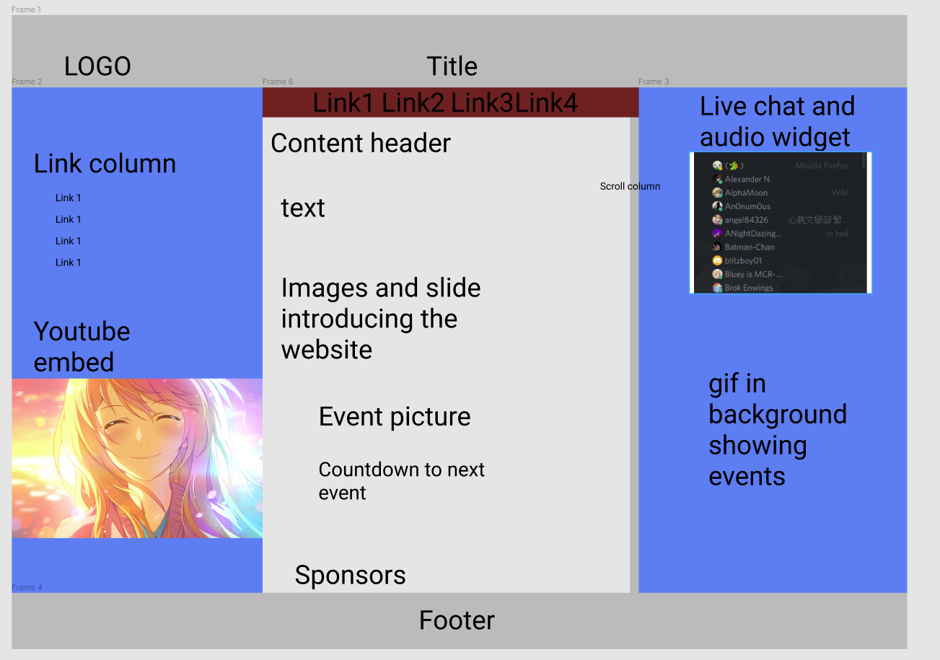

<https://www.figma.com/file/mKlLNqjKbLF4V2RglN3IxR/Untitled?node-id=0%3A1>

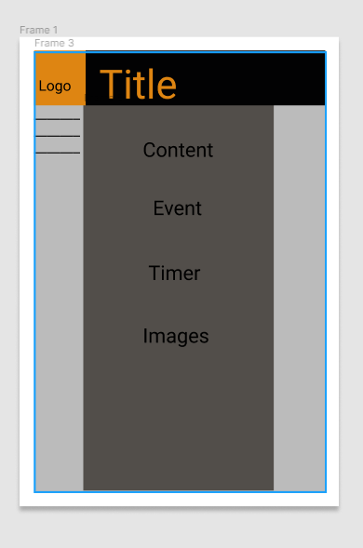

Mobile design prototype for the website to be responsive to other devices this design is a simple yet complex design since html pages are complex and nested designs and layers which throughout this unit will be beneficial on how I learn and progress within the unit.

Task 3

UI and UX stories are in another file but I focused on gamers and gamers alike for Lan events and offerings, although with covid happening at the moment I believe the website for this is a functional project for users and will offer a variety of choices to whoever would like to host or advertise an event.

Task 4

Implementation of discord widget, search bar and hyperlinks Audio and video plug ins to follow.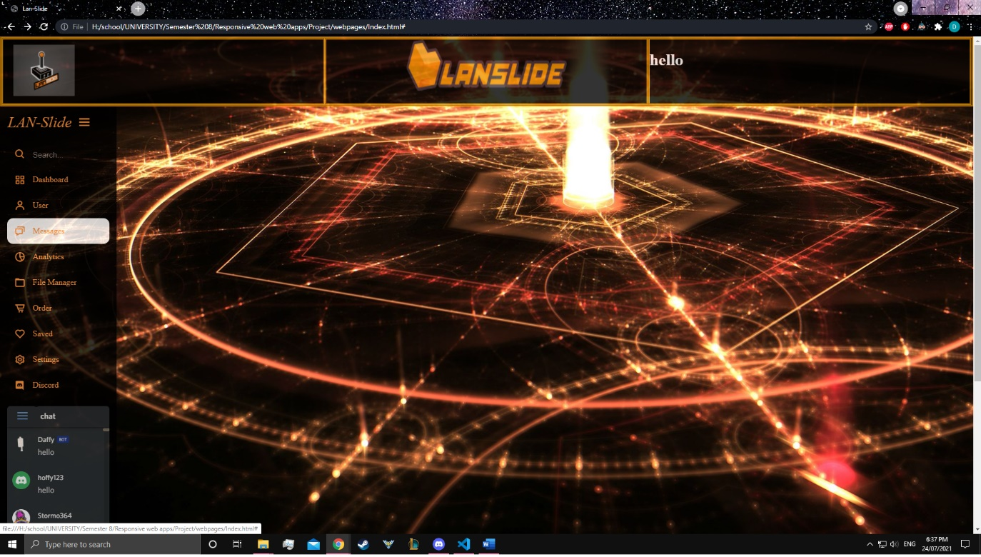

I decided to add a discord functionality and a search bar to eventually implement it on my project, furthermore I will be using video and gif embeds to add to the website. This was extremely difficult due to the work required in order to make the page aesthetically pleasing and functional.

Reflection:

This week’s task and demonstration of elements and functions such as Graphics, media and other APIs are important for website functionality throughout the coming weeks I will be adding additional functionality to the website and make it better over time.